Web Services :-

For making the communication using the web services we need to think about two things
- :- Medium (can be Lan, Internet or anything)
- :- Format of I/p and o/p msg.

We can access web services in two ways:-

1):- Directly access the WSDL file and use the web service. In this case service provider provide the WSDL file to client and client directly use the web service.
2):- By using the UDDI file stored on internet. UDDI store all the WSDL of all the web services provider. Client can hit the UDDI and then find WSDL and then can use the Web Services.

Need to knows:-
WSDL :- web service description language
UDDI :- Universal description discovery and integration :- Its a directory on internet where all the service need to register their web services with UDDI using their WSDL file.
Any client want to use web service then he hit uddi and would search for a particular web service

- Client search for a service in UDDI.
- UDDI return all the service Providers offering that service
- Client choose one service provider and get WSDL.
- With the help of WSDL client access the web service

Web Services are of two Type :-
1):- REST
2):- SOAP

1):- REST :- Client can access the resource directly from URI.
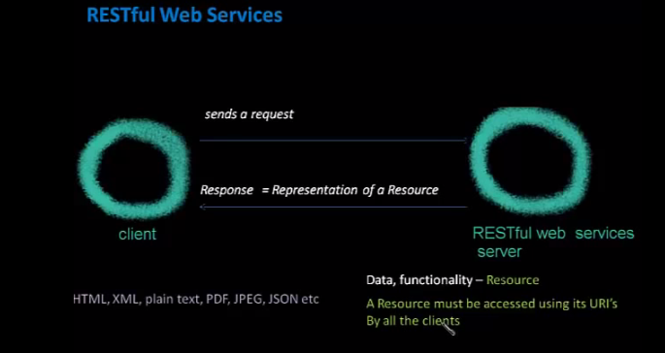

3 Main Feature
a):- In Restful web service client can directly call the web services using URI but in SOAP based web services client need to have WSDL file and its stub to access anything in web service.
b):- Self descriptive message → it means that response contains the information of format and in which format client read the response.
c):- Uniform Resource :- Restful services uses HTTP protocal. We can use other as well. But HTTP describe it greatly

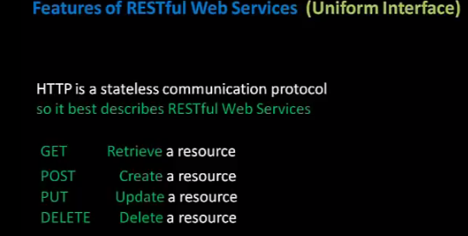

QueryParam vs PathParam

PathParam :- In this Parameter are passed using the URL after “/” as a parameter
Ex:- http://8092/StudentController/12/15
Here 12 is the class nane and 15 is the studentId

Function would be :-

package com.restfulService;

import javax.ws.rs.GET;
import javax.ws.rs.PUT;
import javax.ws.rs.Path;
import javax.ws.rs.PathParam;
import javax.ws.rs.Produces;
import javax.ws.rs.core.MediaType;

@Path("/student")
public class StudentService
{
@GET
@Path("{classInfo}/{studentInfo}")
public String GetUniversityHTMLName2(@PathParam("classInfo") String classNumber, @PathParam("studentInfo") String stuInfo)
{
return "Student Id :- " + stuInfo + "With class no. :- " + classNumber;
}
}

@QueryParam :-

If the parameter is mentioned in the format of Query String in the Http URL - Then those parameter are known as “Query Parameter”

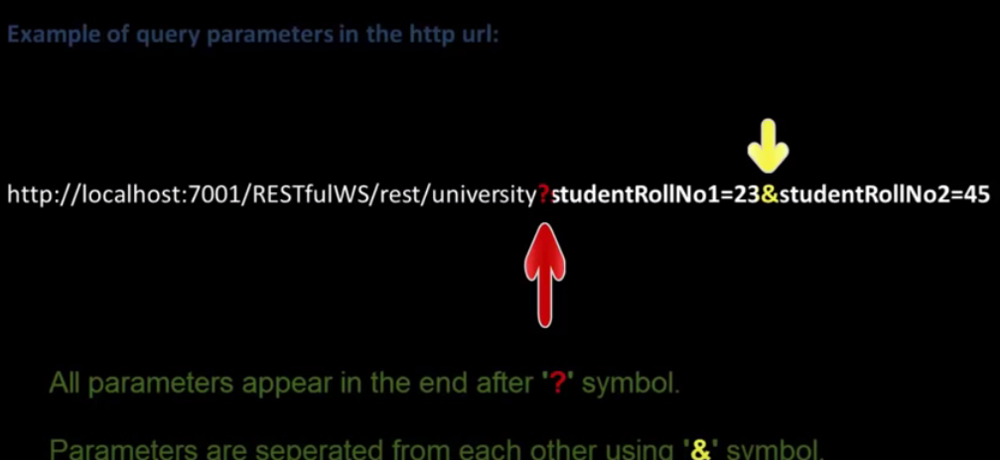

Function :-

@GET
@Path("/queryParamExample")
public String GetStudentInfoUsingQueryParam(@QueryParam("studentRollNo1") String studentRN1, @QueryParam("studentRollNo2") String studentRN2)
{
return "Query Param Example :---- >>>>> Student Id :- " + studentRN1 + "And Student Id : - " + studentRN2;
}

MatrixParam : - >

It is also used to defining the parameter anywhere in the URI.
Parameter are seprated by “;”.
There is no limit oif defining the parameter.
Parameter is apper anywhere in the URL

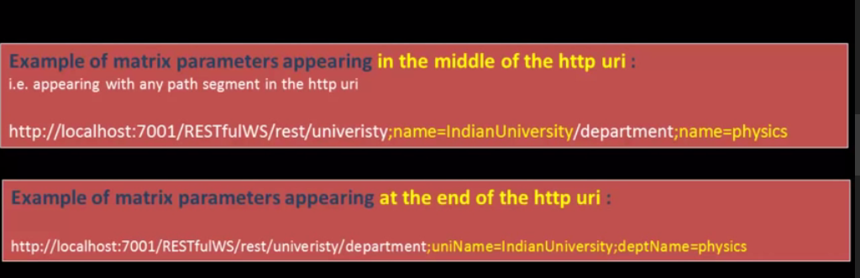

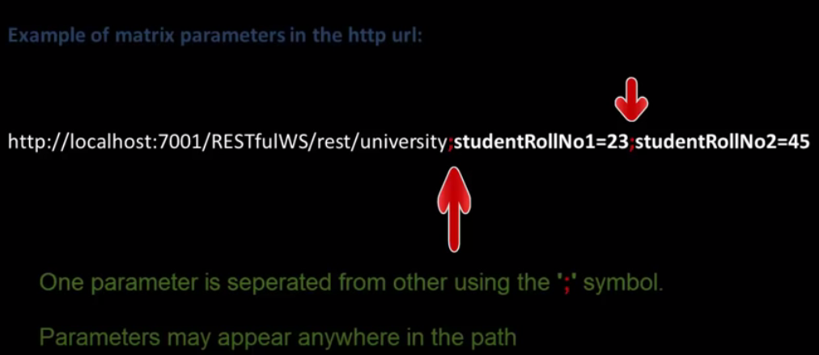

@GET
@Path("/matrixParamExample")
public String GetStudentInfoUsingMatrixParam(@MatrixParam("studentRollNo1") String studentRN1, @MatrixParam("studentRollNo2") String studentRN2)
{
return "Matrix Param Example :---- >>>>> Student Id :- " + studentRN1 + " and Student id : - " + studentRN2;
}

FormParam : - >

It is also used to fetch the form parameter.
Parameter are defined by the name when you define any field inside the form.
We are using the post for submitting the form because when we use POST it will send the parameter in to the body.
Note :- GET NOT USED :- If we use method as GET then it will send it into the URL.

Example:-Html File and a controller file
<form action="http://localhost:7001/UniversityRestfulWSDemo/rest/student/formParamExample" method="POST">
<input type="text" name="classId"/>
<input type="text" name="studentId"/>
<input type="submit" value="submit"/>
</form>

Controller File:-
@POST
@Path("/formParamExample")
public String GetStudentInfoUsingFormParam(@FormParam("classId") String classNumber, @FormParam("studentId") String stuInfo)
{
return "Form Param Example :---- >>>>> Student Id :- " + stuInfo + "With class no. :- " + classNumber;
}

How to provide security in RESTFUL Web Services ?

We need to provide extra configuration for that.
<security-constraint>
<web-resource-collection>
<url-pattern>/rest/test/save</url-pattern>
<http-method>PUT</http-method>
</web-resource-collection>
<auth-constraint>
<role-name>admin</role-name>
</auth-constraint>
</security-constraint>
<login-config>
<auth-method>BASIC</auth-method> <!--We have diff. Methods as well -->
</login-config>

This will asking me for username and password for role admin and it will check this username/password is exist in tomcat file (tomcat-users.xml).
In tomcat we have configuration like this:
<role rolename="tomcat"/>
<role rolename="member"/>
<role rolename="admin"/>
<user username="akshay" password="akshay" roles="tomcat,member,admin"/>
<user username="member" password="member" roles="tomcat,member"/>
<user username="admin" password="admin" roles="tomcat,admin"/>

